AI ASSISTED CODING
NAME: N.RUKMINI
ENROLL NUMBER: 2403A52402
BATCH NUMBER :14

Lab assignment-12.4
Task 1: Implementing Bubble Sort with AI Comments
- Task: Write a Python implementation of Bubble Sort.
- Instructions:
  - Students implement Bubble Sort normally.
  - Ask AI to generate inline comments explaining key logic (like swapping, passes, and termination).
  - Request AI to provide time complexity analysis.
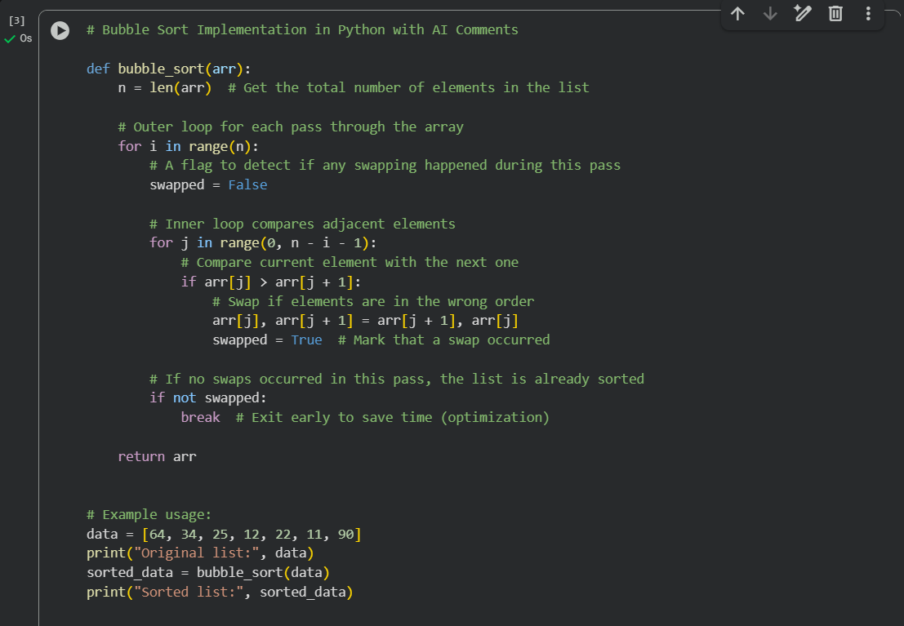
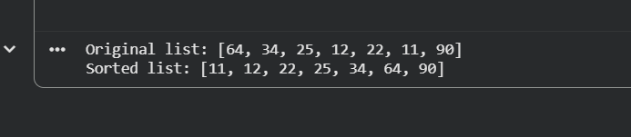

Task 2: Optimizing Bubble Sort → Insertion Sort
- Task: Provide Bubble Sort code to AI and ask it to suggest a more efficient algorithm for partially sorted arrays.
- Instructions:
  - Students implement Bubble Sort first.
  - Ask AI to suggest an alternative (Insertion Sort).
  - Compare performance on nearly sorted input.
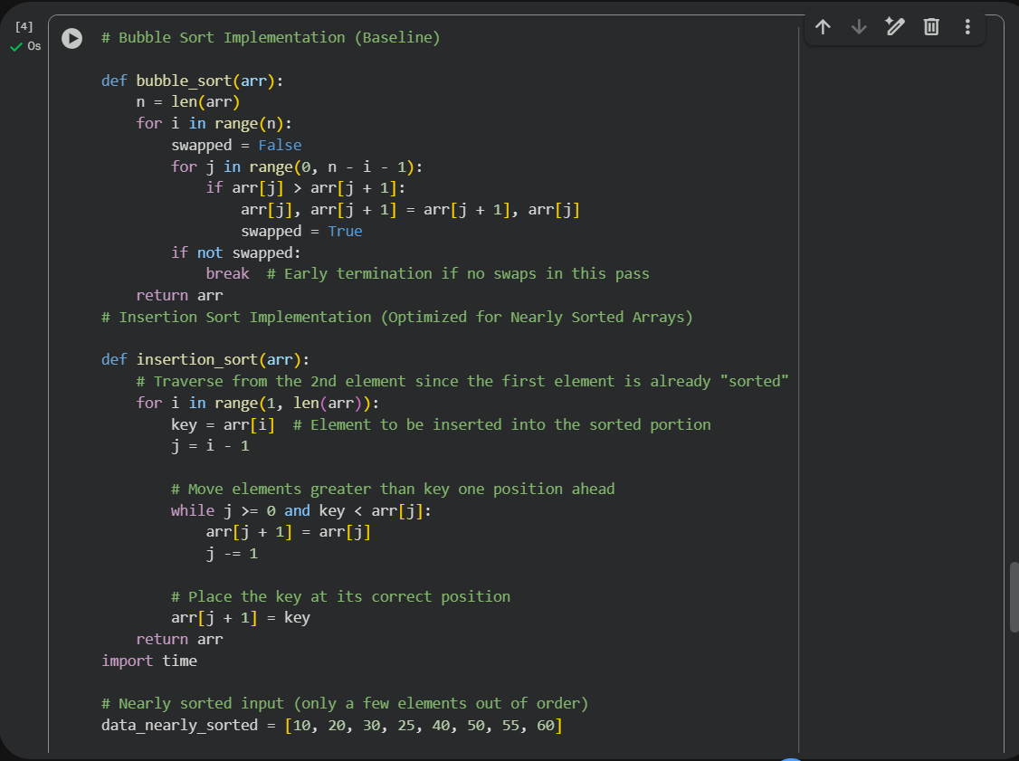
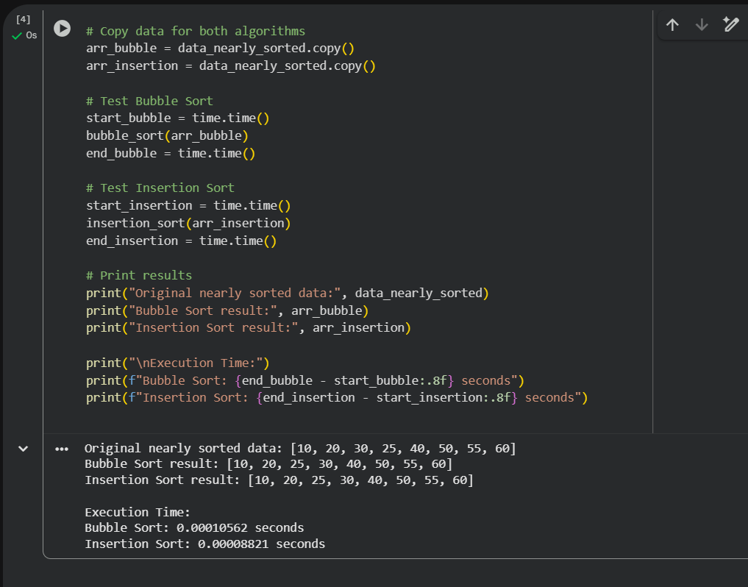
Task 3: Binary Search vs Linear Search
- Task: Implement both Linear Search and Binary Search.
- Instructions:
  - Use AI to generate docstrings and performance notes.
  - Test both algorithms on sorted and unsorted data.
Ask AI to explain when Binary Search is preferable
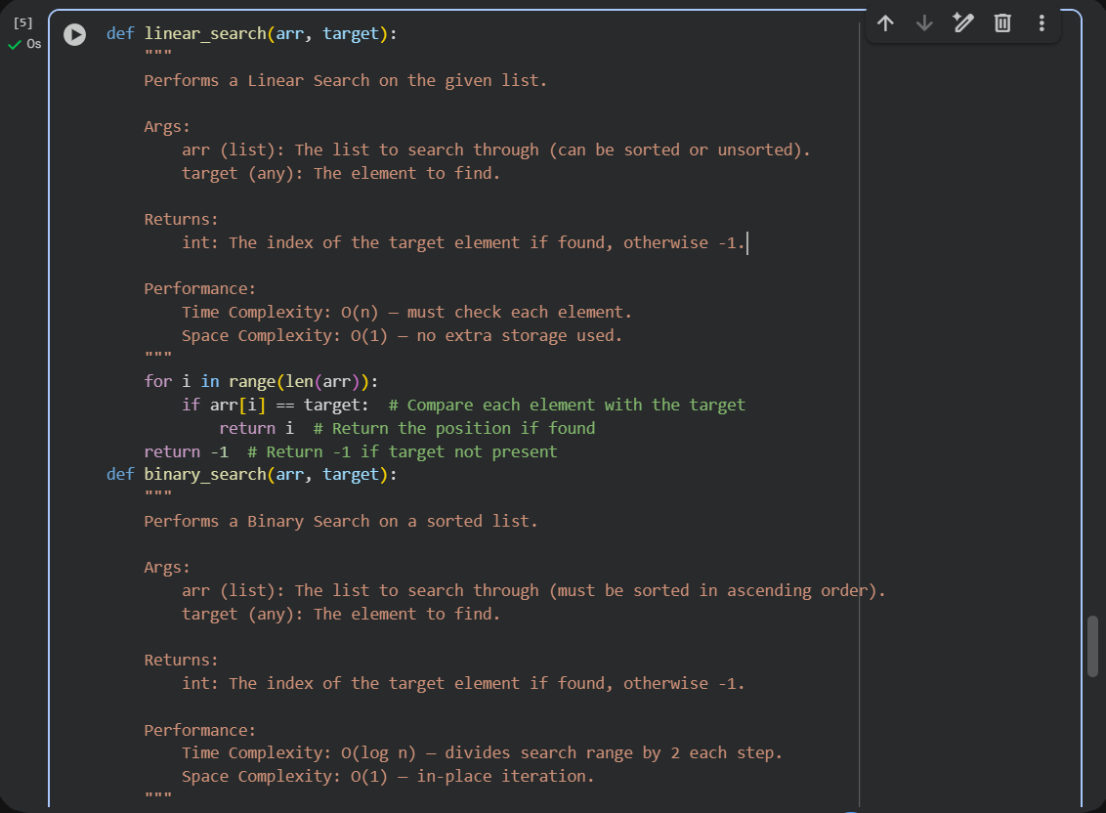
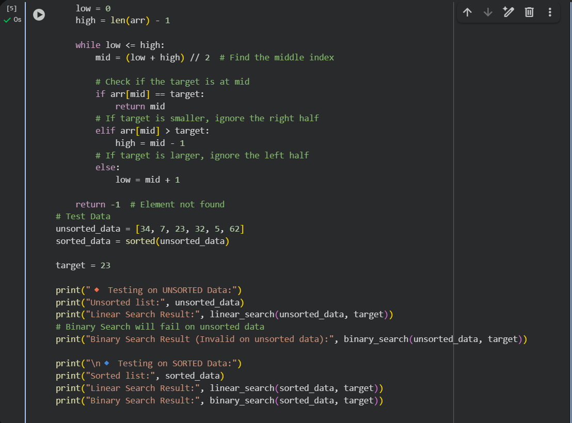
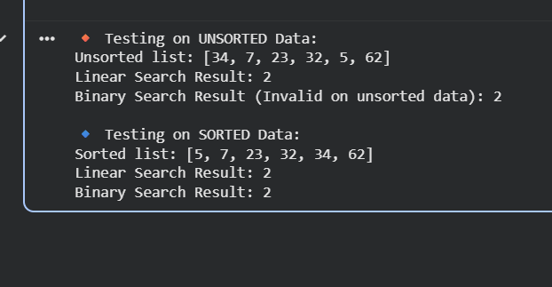
- Task 4: Implement Quick Sort and Merge Sort using recursion.
- Instructions:
  - Provide AI with partially completed functions for recursion.
  - Ask AI to complete the missing logic and add docstrings.
Compare both algorithms on random, sorted, and reverse-sorted lists
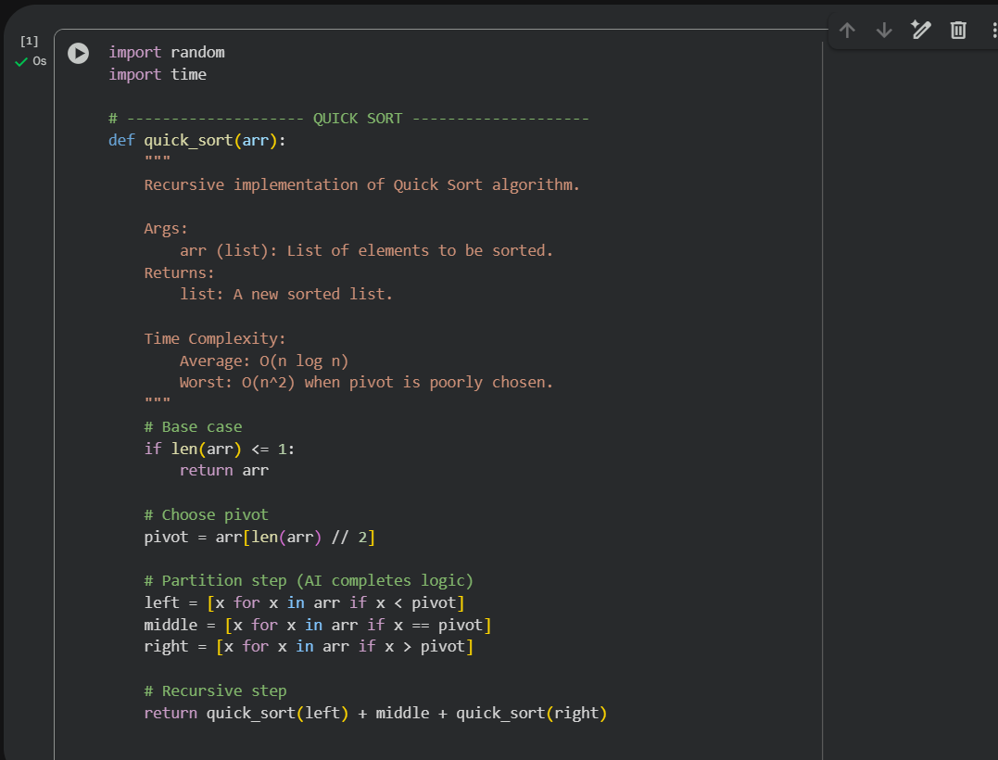
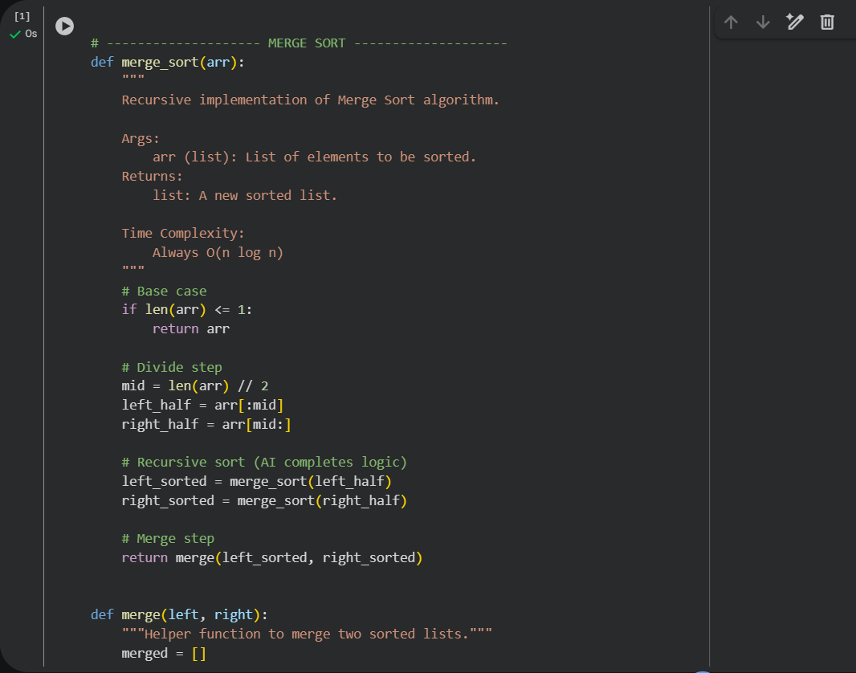
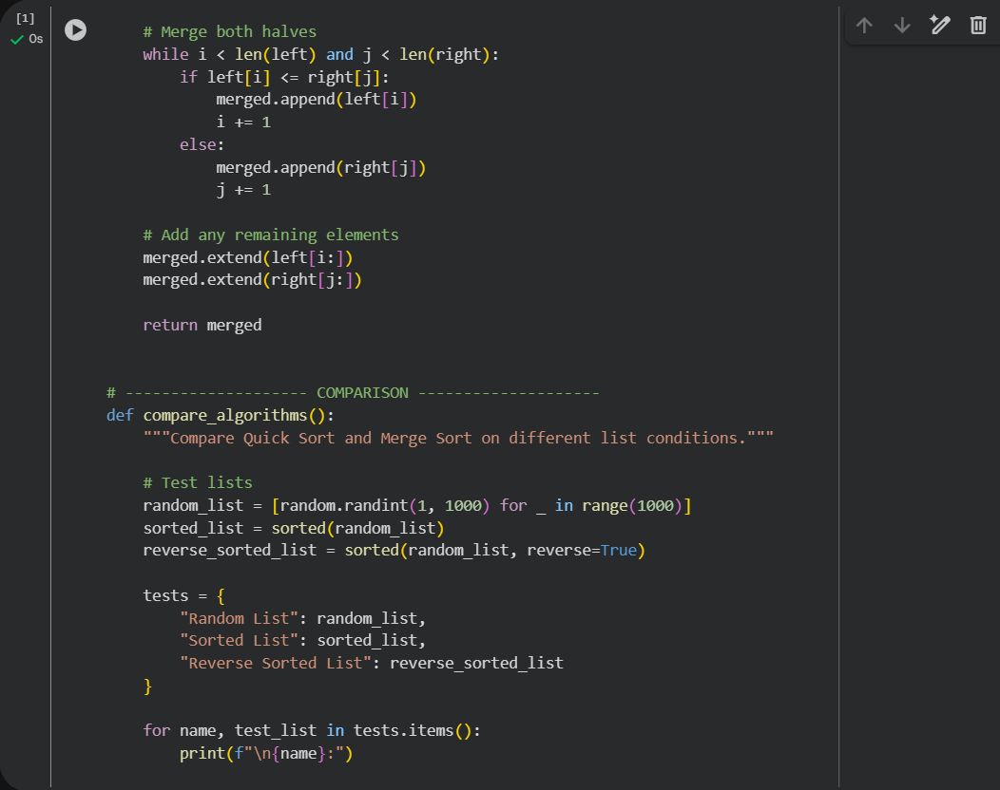
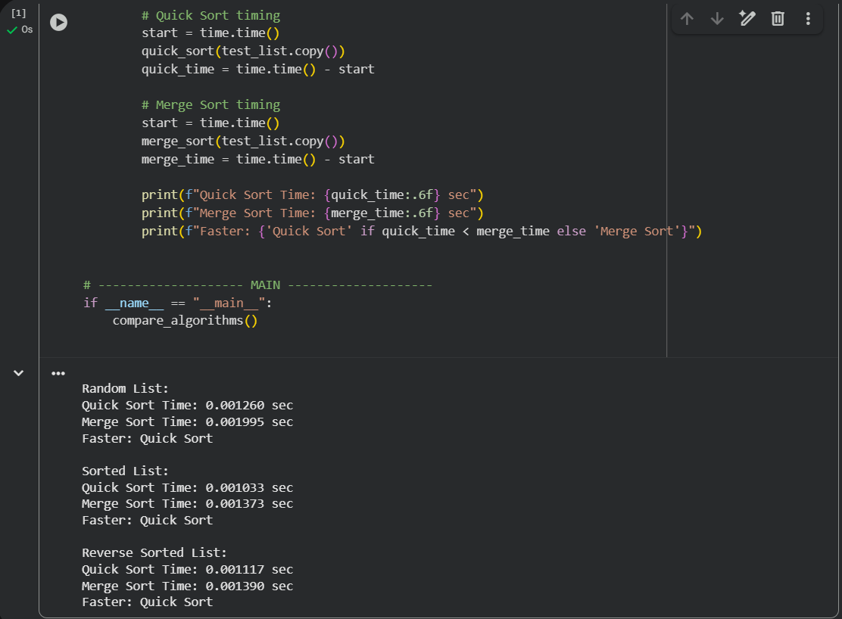
Task 5: AI-Suggested Algorithm Optimization
- Task: Give AI a naive algorithm (e.g., O(n²) duplicate search).
- Instructions:
  - Students write a brute force duplicate-finder.
  - Ask AI to optimize it (e.g., by using sets/dictionaries with O(n) time).
Compare execution times with large input sizes
